Tree Festival Booking Form
Jedburgh 2025 Festival.
Please fill the form in and email to events@thejedeye.co.uk
or return to The Jed Eye Centre, 3 Castlegate, Jedburgh.

Name
Organisation
(if applicable)
Position in Organisation
(if applicable)
Email

Telephone

Address

A short paragraph to use in the brochure that tells us about you, your company or organisation.

Availability for stewarding | (Yes/No)

Payment of £40 required to book your tree and space in the festival, and cover  publicity costs.  (Free to Charities and community groups) | By Bacs transfer  Acc Name: Jedburgh & District Community News Group  Acc No: 00207621  Sort Code: 83-23-14  or you can pay in The Eye Centre by card or scan the QR code below  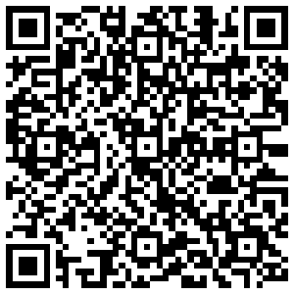
NB – You will need your own decorations and lights (battery powered)
All trees will be at the Church ready for you to decorate as you wish but following the theme of Traditions.

Trees must be decorated between Wednesday 26th November and Friday 28th November Church opening times will be sent with booking confirmation.
There will be a prize for the best decorated tree, voted for by the public.

